Name Deepthikha H

Batch DA | TN - ANB03

Email ID [hdeepthikha@gmail.com](mailto:hdeepthikha@gmail.com)

Mobile 6379336196

Mentor name Kumaran M

Project Title Employment Analysis Dashboard

Dataset Link [RawDataset_MiniProject_Employee.xlsx](https://docs.google.com/spreadsheets/d/1hjEZhz6YQTLbGPGDoKdoF3y0LJ5vHGUj/edit?gid=211149200#gid=21114920)

Cleaning [MiniProject_DataCleaning](https://docs.google.com/document/d/1Y8UDrzEFi-Wk2L-bSTa_4eobO5_rH6d1PTqRKuxbqv0/edit?usp=sharing), [MINIPROJECTDATASET.xlsx](https://docs.google.com/spreadsheets/d/1YBqhG9238YWw7mulYnUPMb4rfejOCGEQ/edit?usp=sharing&ouid=113413909186192660360&rtpof=true&sd=true)

Visualization [MiniProject_Visualization](https://docs.google.com/document/d/1qEJbu9M9secBBFFLCvN-Tozu2Zn3iq8aAGbiM7en0U4/edit?usp=sharing)

**Cleaning :**

1) Find and Replace

2) Find mode using Group by function

3) Finding Average ()

4) Date Format

5) If(Isblank())

6) VLOOKUP()

7) Joining two table

8) Calculated column

**Data Cleaning :**

1) Find and Replace :

The "Employee Name" column in the dataset contained numerous blank cells, which were filled using the Find and Replace function.

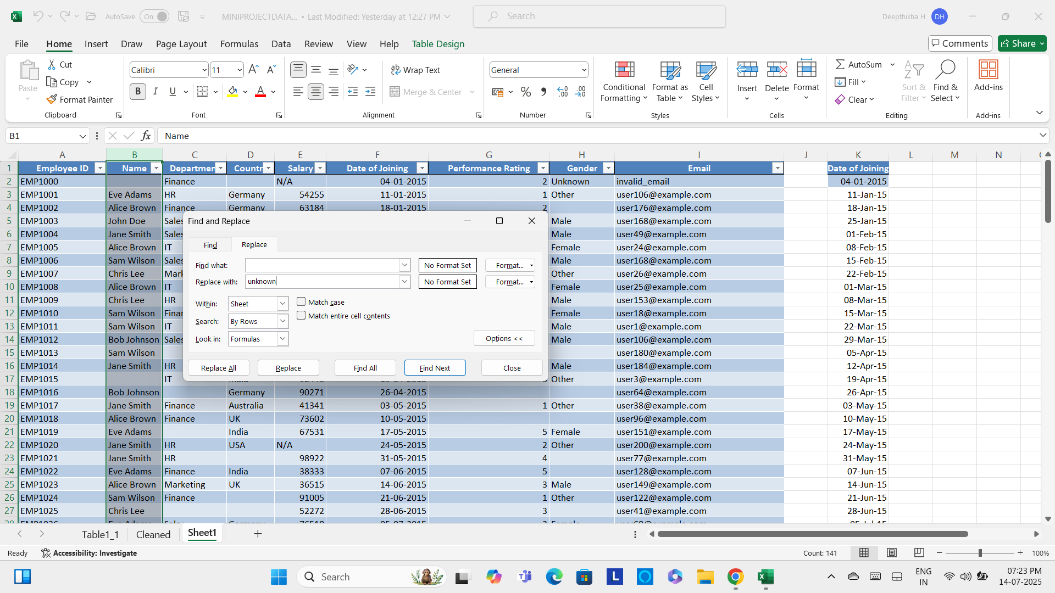

2) Find mode using Group by function :

The "Department" column contained numerous blank cells. The mode was identified using the Group By function in Power Query, and the blank cells were filled using the Find and Replace function.

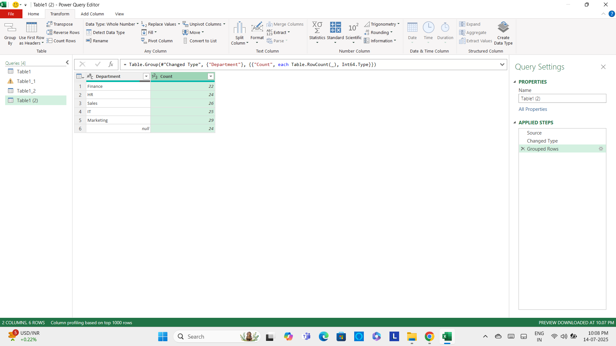

Some cells in the "Country" column contained null values, while others had spaces as values. The space values were converted to null, and all null cells were then filled with the mode, "India."

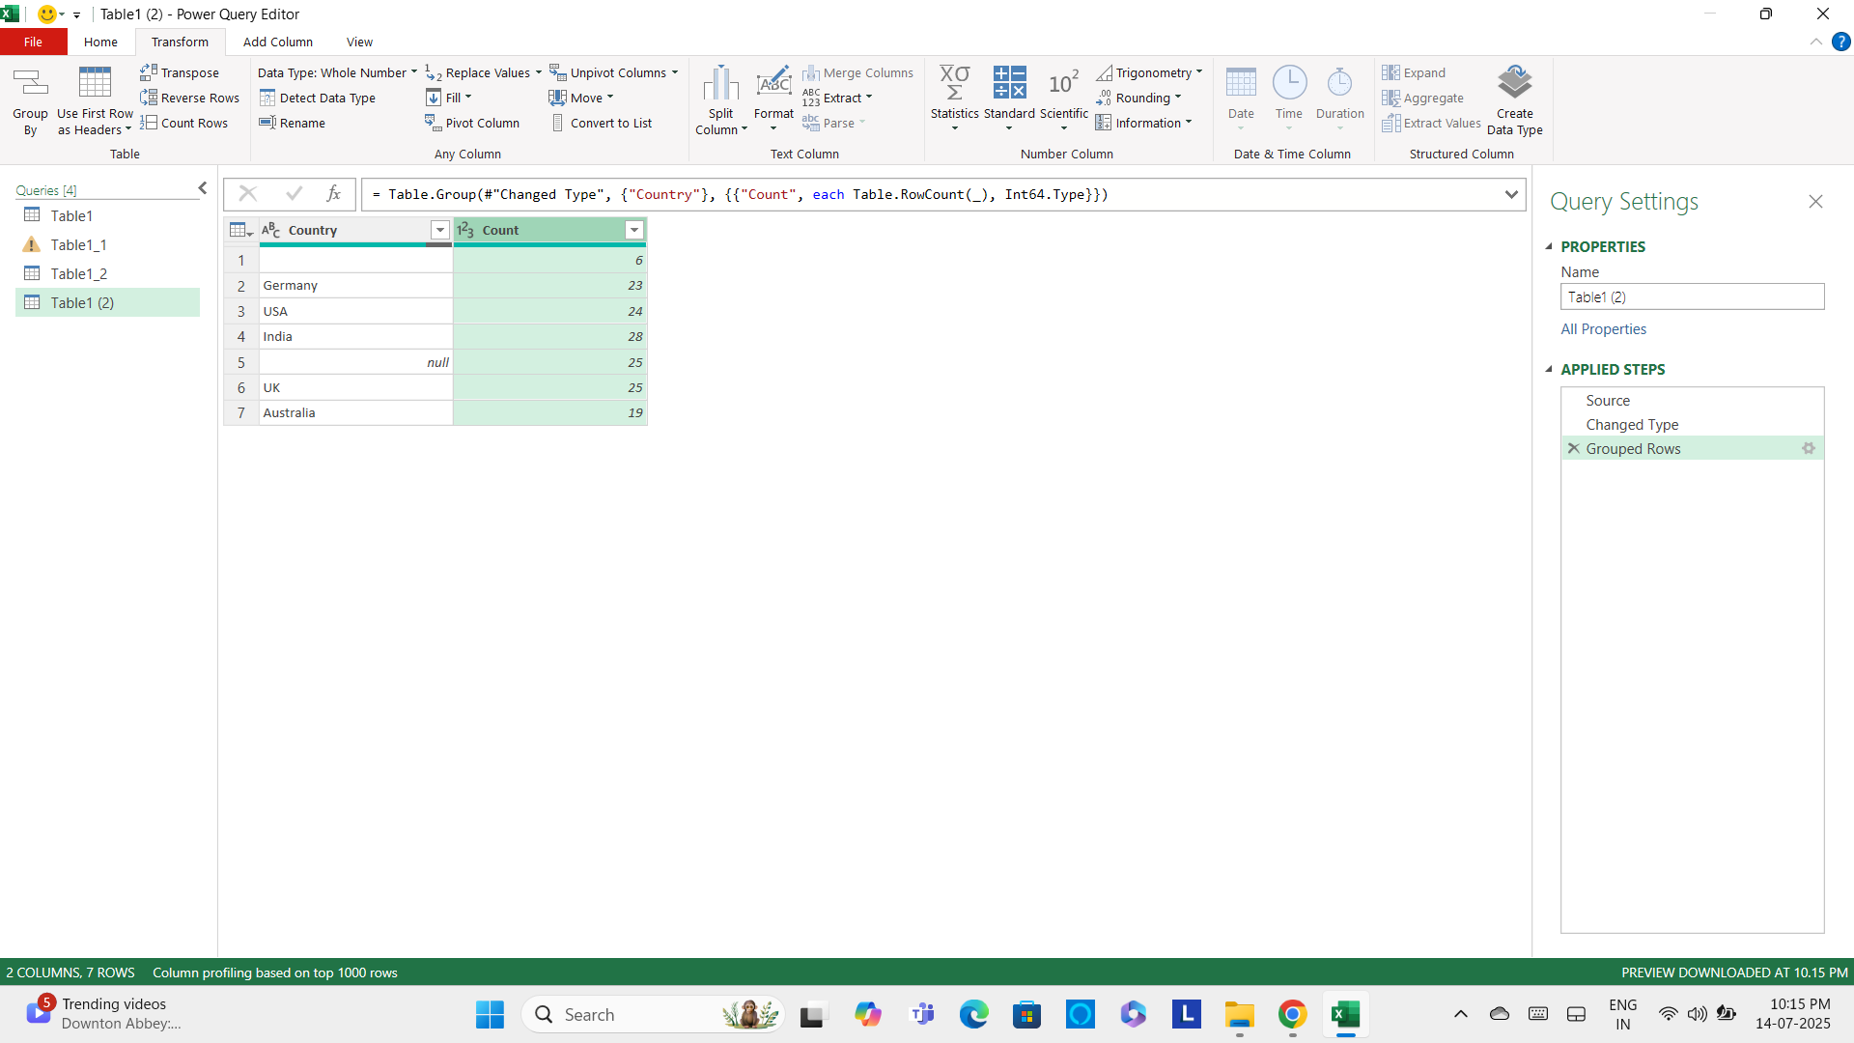

The "Performance" column contained blank cells, which were addressed by identifying the mode of the column. The blank entries were then replaced with the mode value, "1", to ensure consistency.

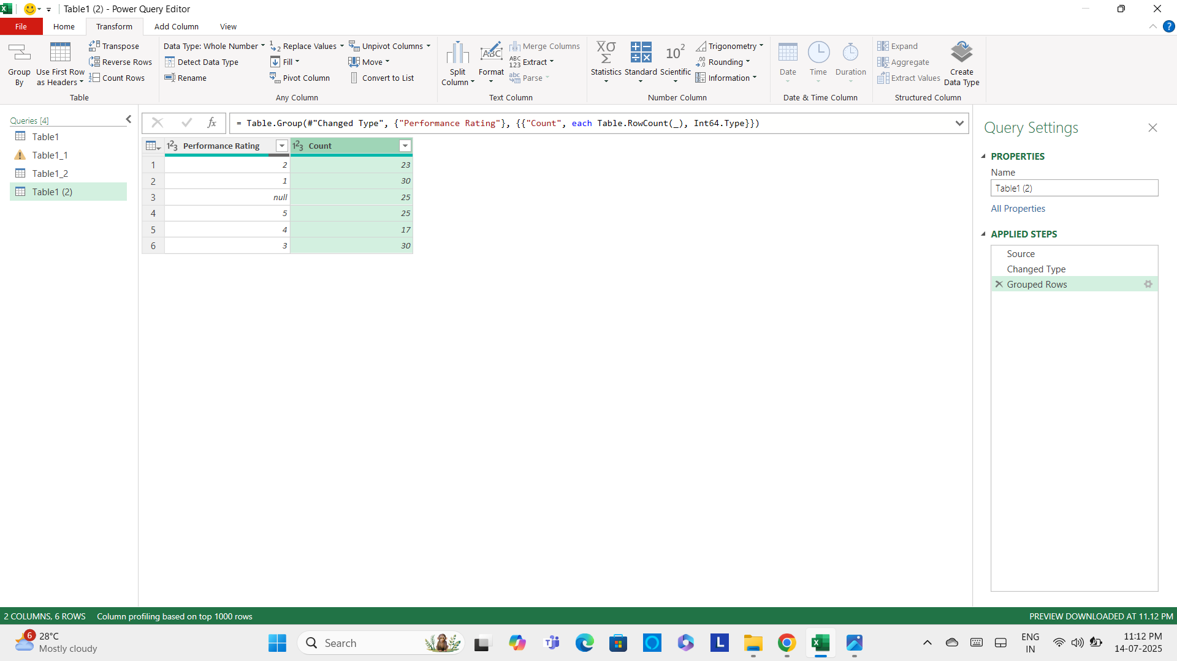

Null entries within the "Gender" column were imputed using the modal value, "Female," to maintain data integrity.

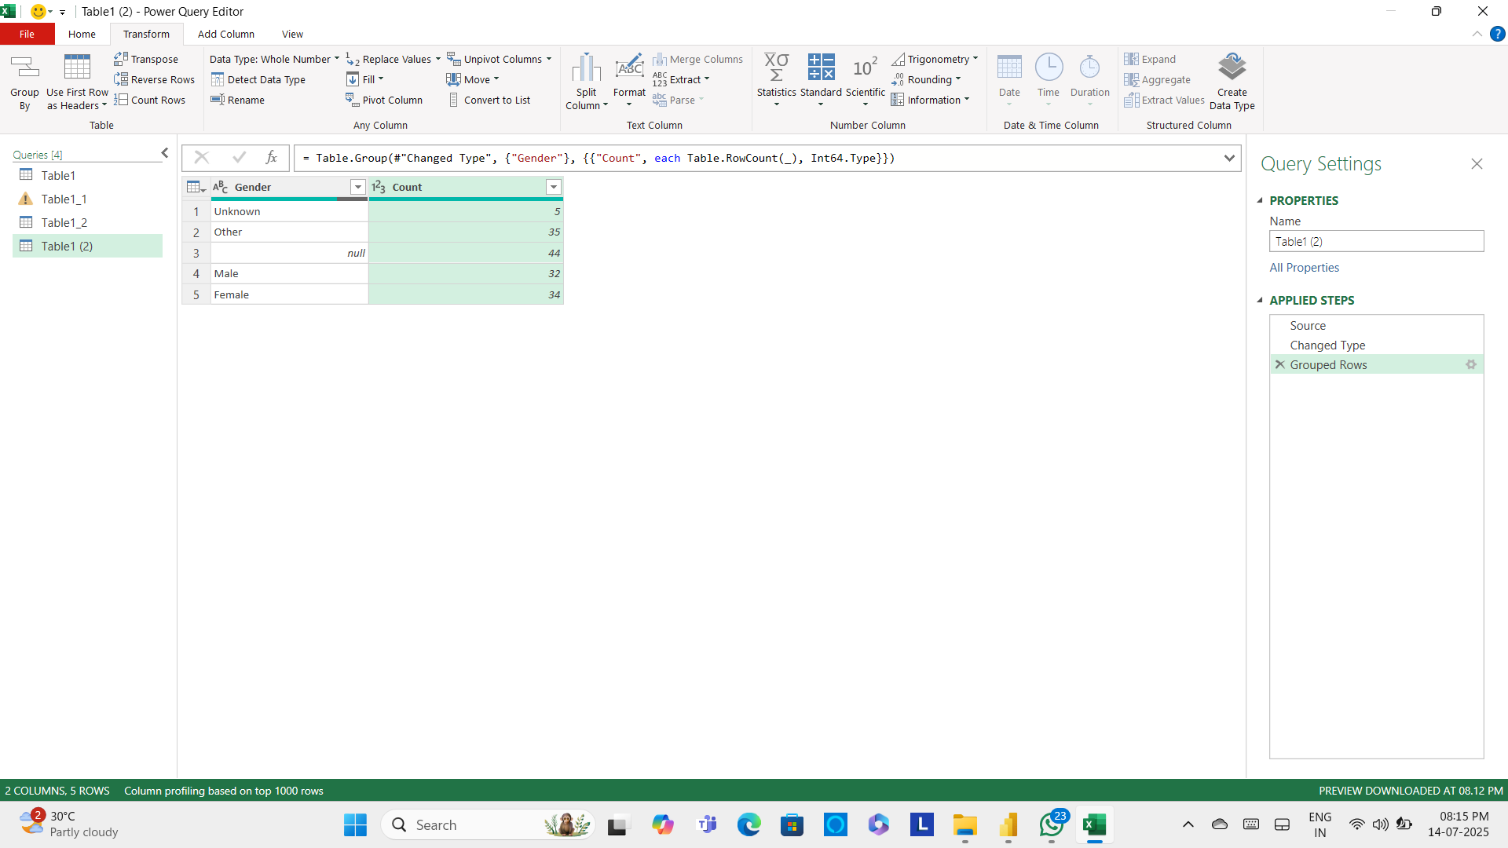

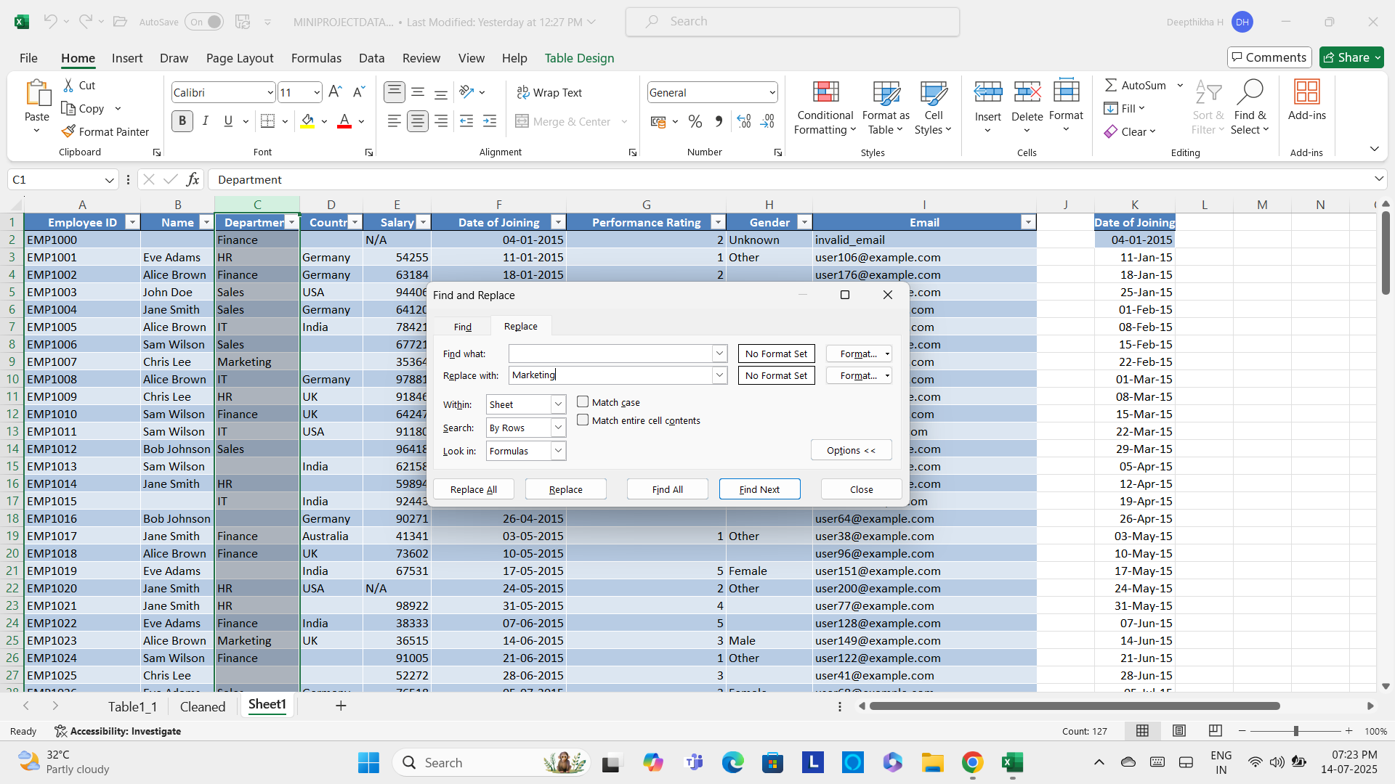

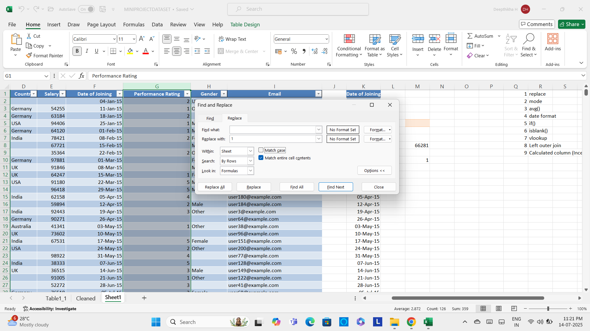

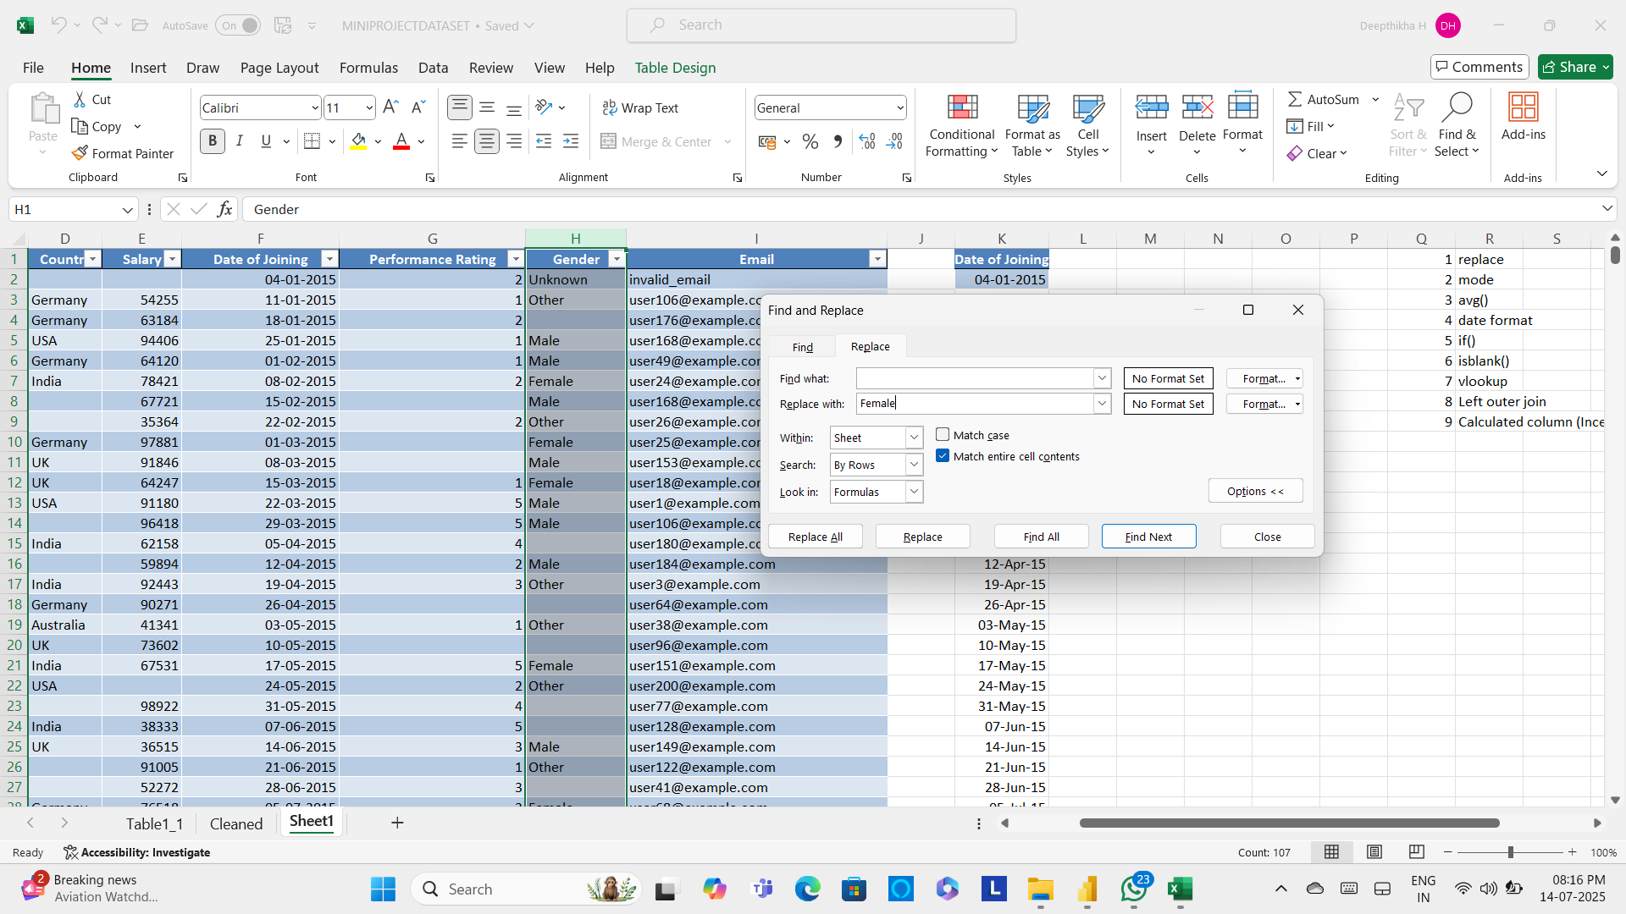

3) Finding Average () :

The "Salary" column exhibited multiple blank entries. To rectify this, the mean salary value was computed and subsequently imputed into the vacant cells to ensure data consistency.

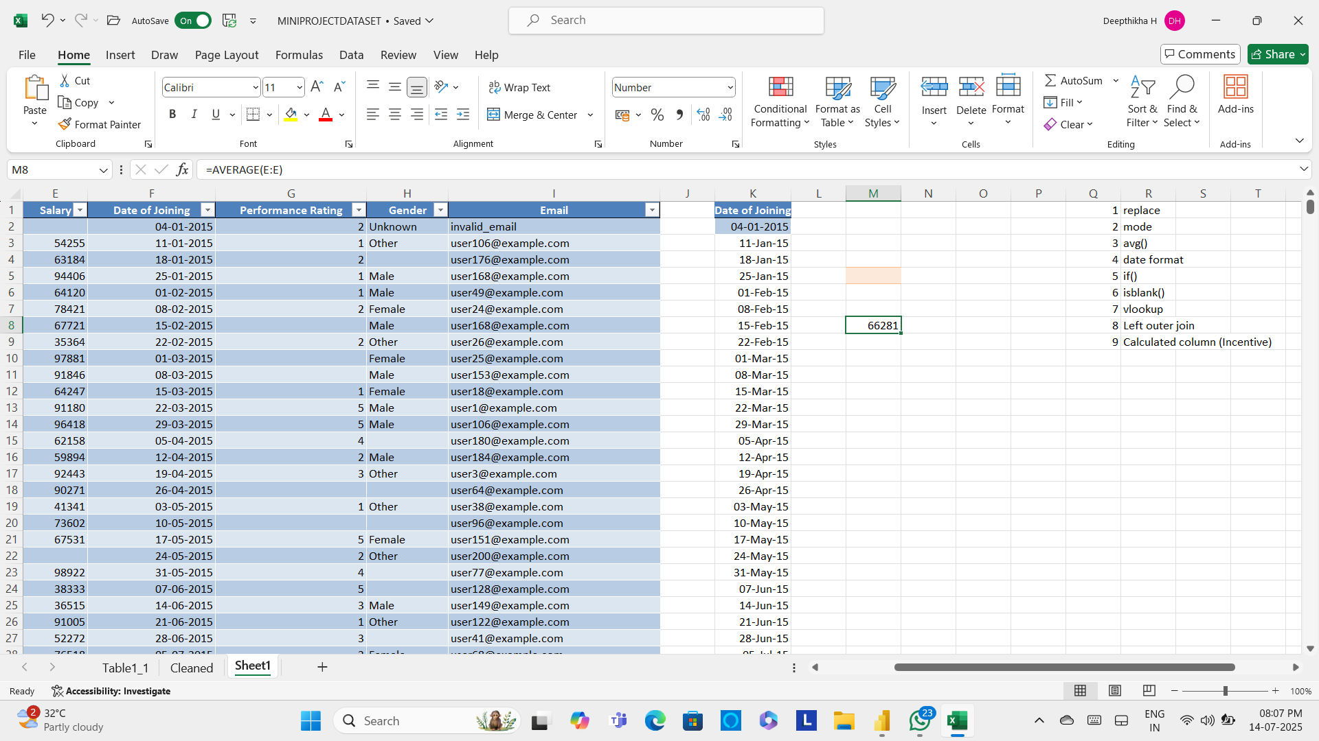

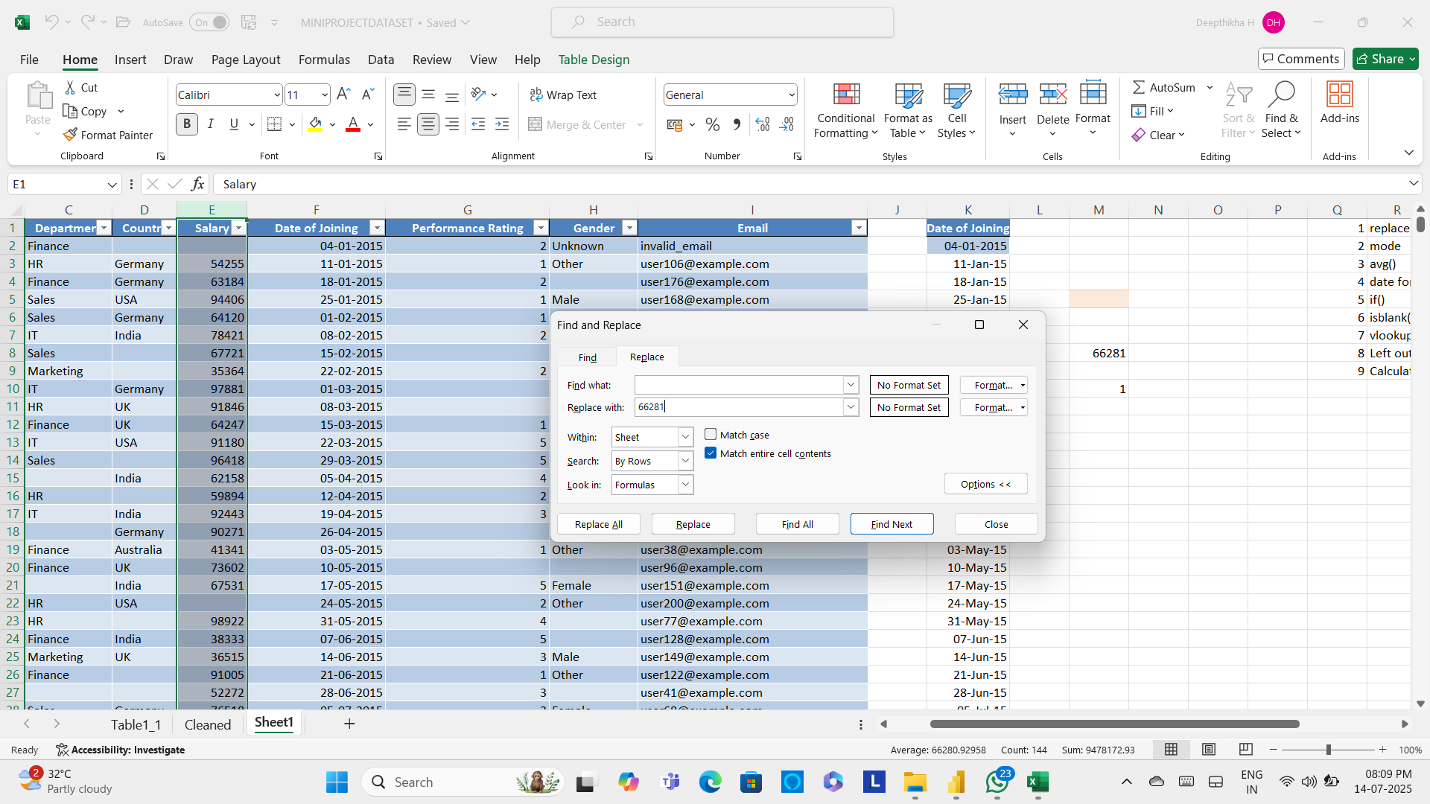

4) Date Format :

The "Date" column in the dataset contained several empty cells. Observing that each date followed a consistent 7-day interval from the previous entry, the missing values were filled by adding 7 days to the preceding date.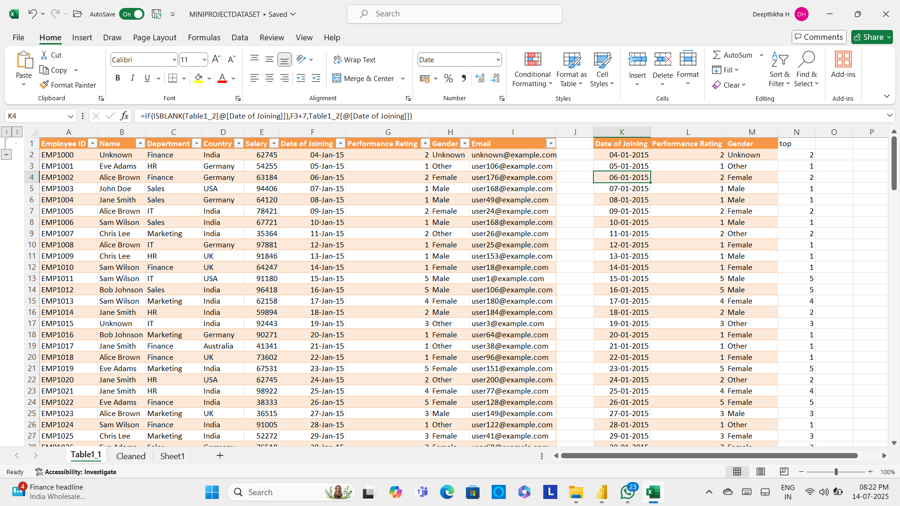

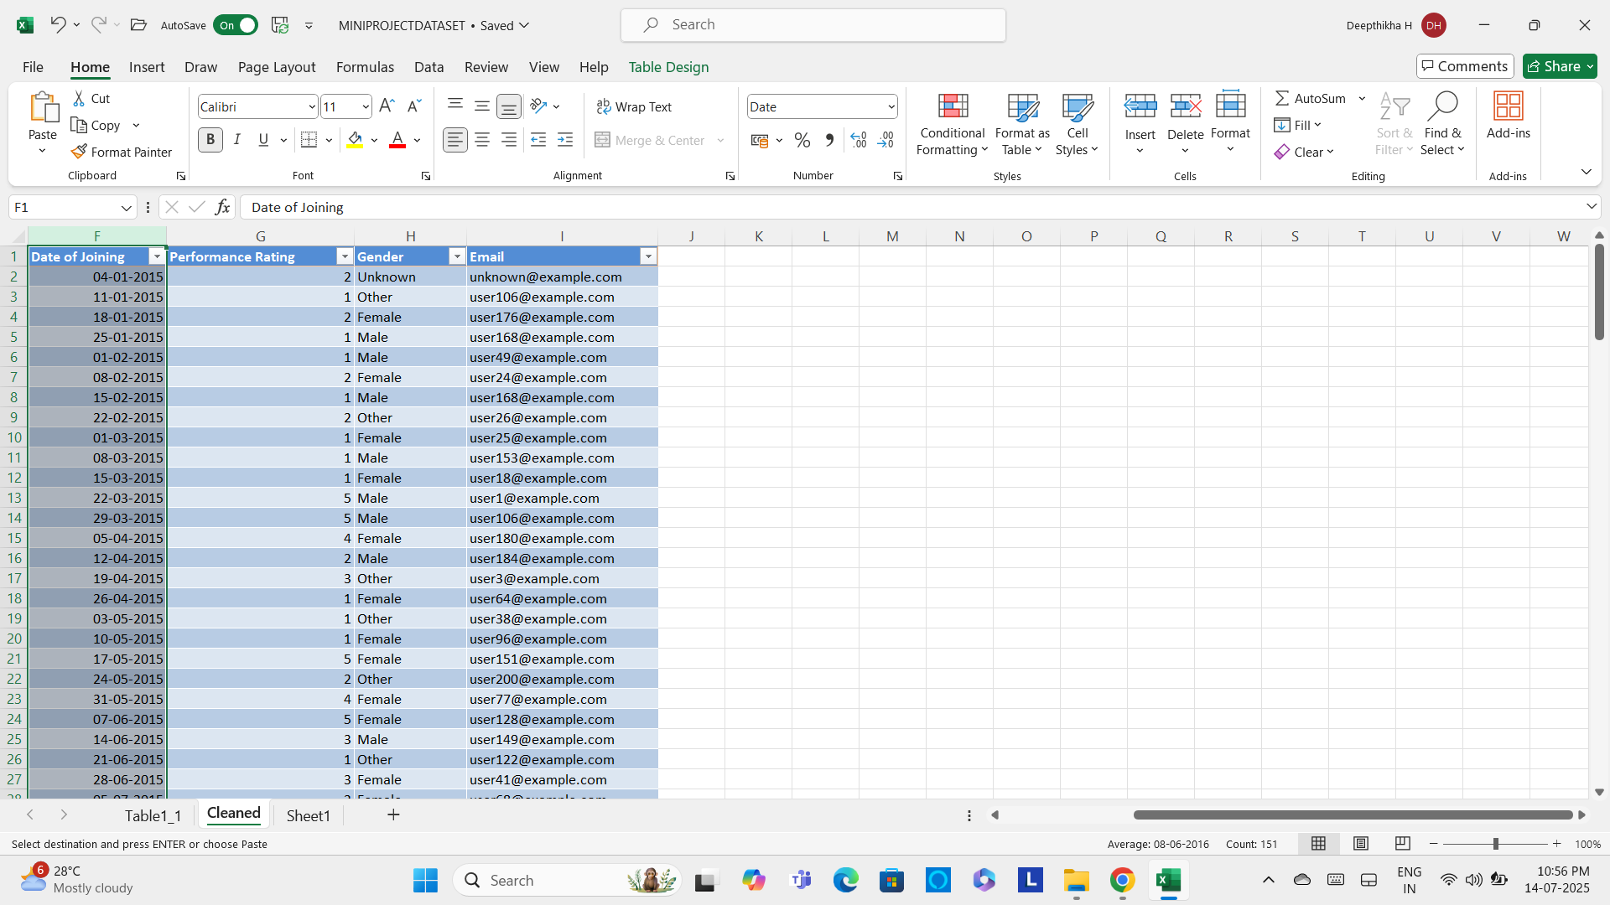

5) If(ISblank()) :

The above logic was implemented using a combination of the IF() and ISBLANK() functions to dynamically identify and populate the empty cells.



6) VLOOKUP() :

The VLOOKUP() function was employed to extract and consolidate specific columns into a separate worksheet, thereby facilitating enhanced data visualization and improved structural coherence.

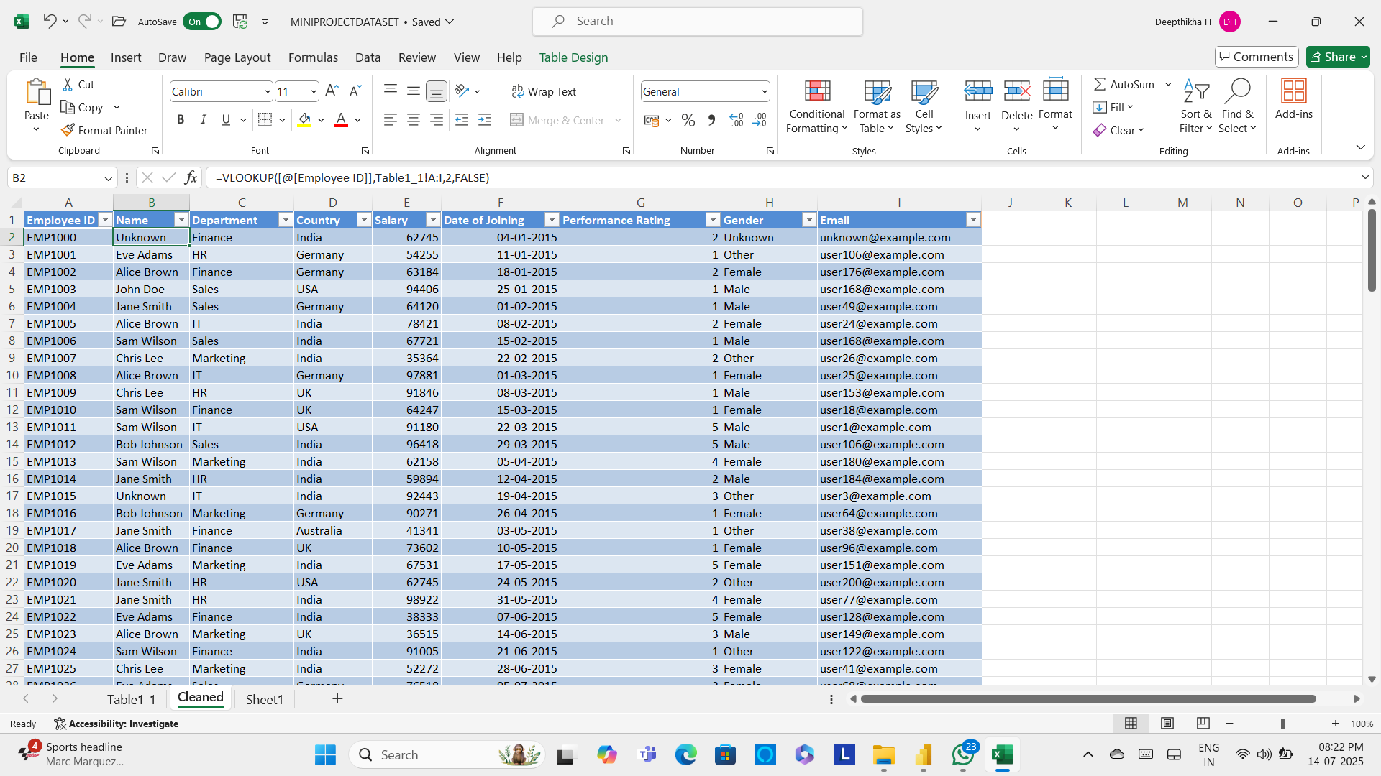

7) Joining two table :

The Merge function was employed to integrate two distinct tables through a left outer join, utilizing the "Department" field as the key relational attribute, thereby ensuring the preservation of all records from the primary table while appending matching data from the secondary table.

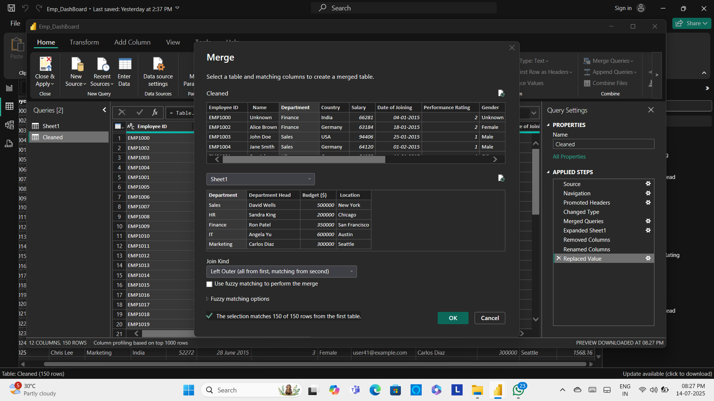

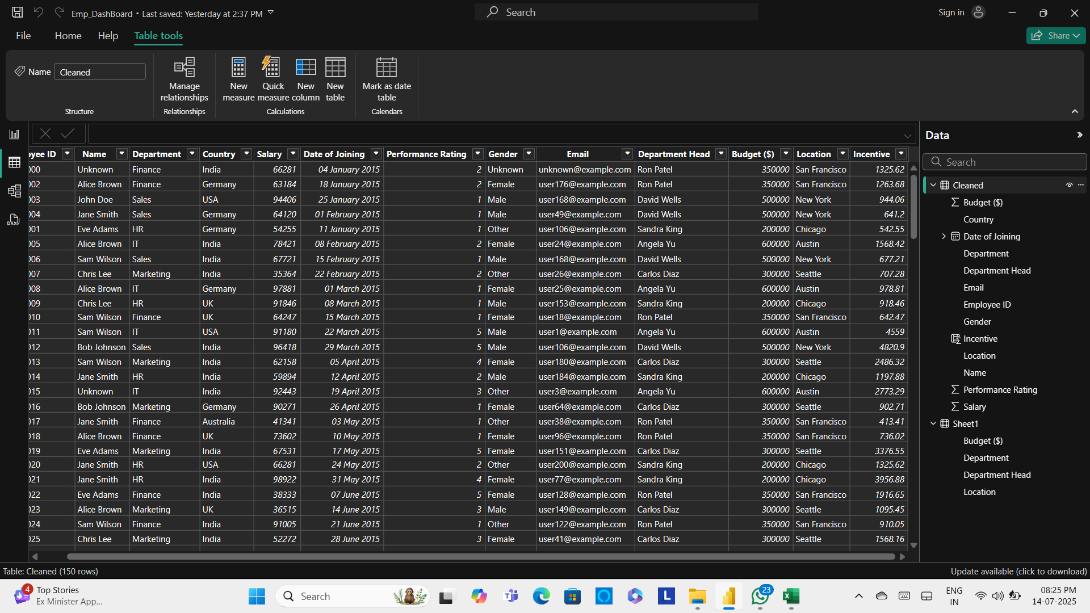

8) Calculated column :

A new calculated column, designated as "Incentives," was derived through a computed expression that integrates both the "Salary" and "Performance Rating" variables, enabling a dynamic assessment of employee-based incentive values.

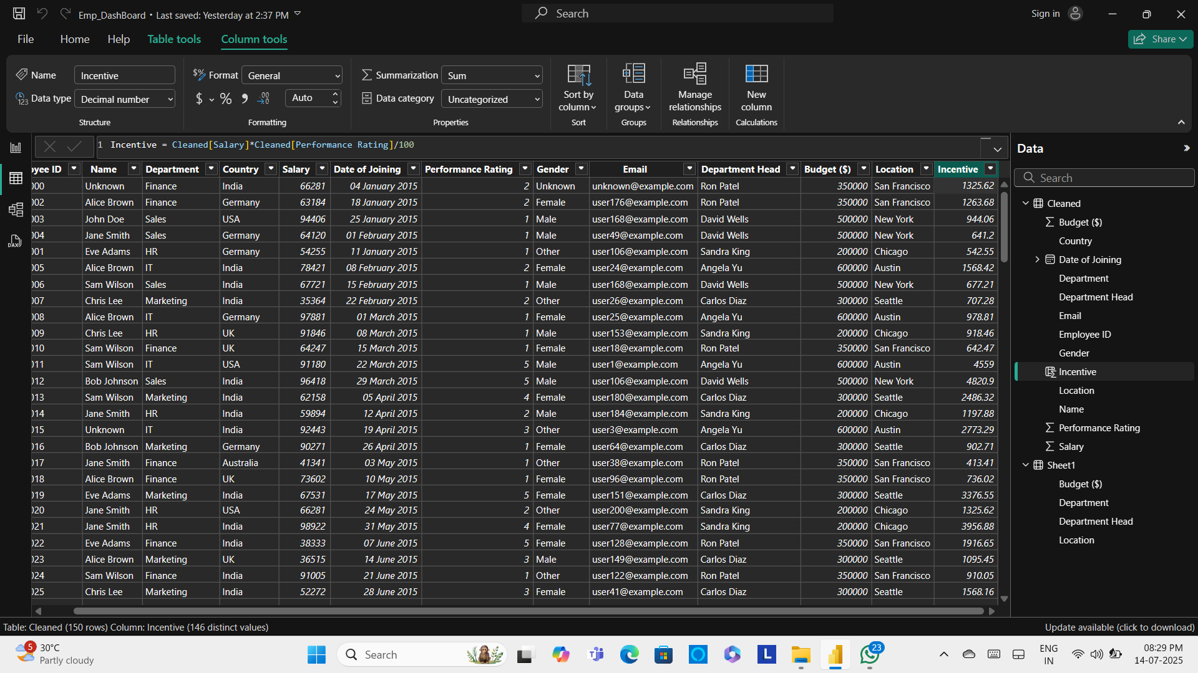

**Data visualization :**

1) Pie chart:

The total budget was calculated and displayed for each department.

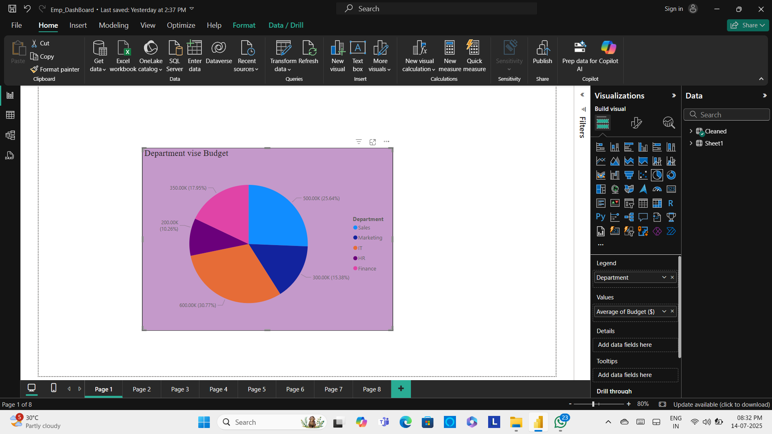

2) 100% Stacked Column Chart :

Performance ratings were analyzed and displayed based on each department.

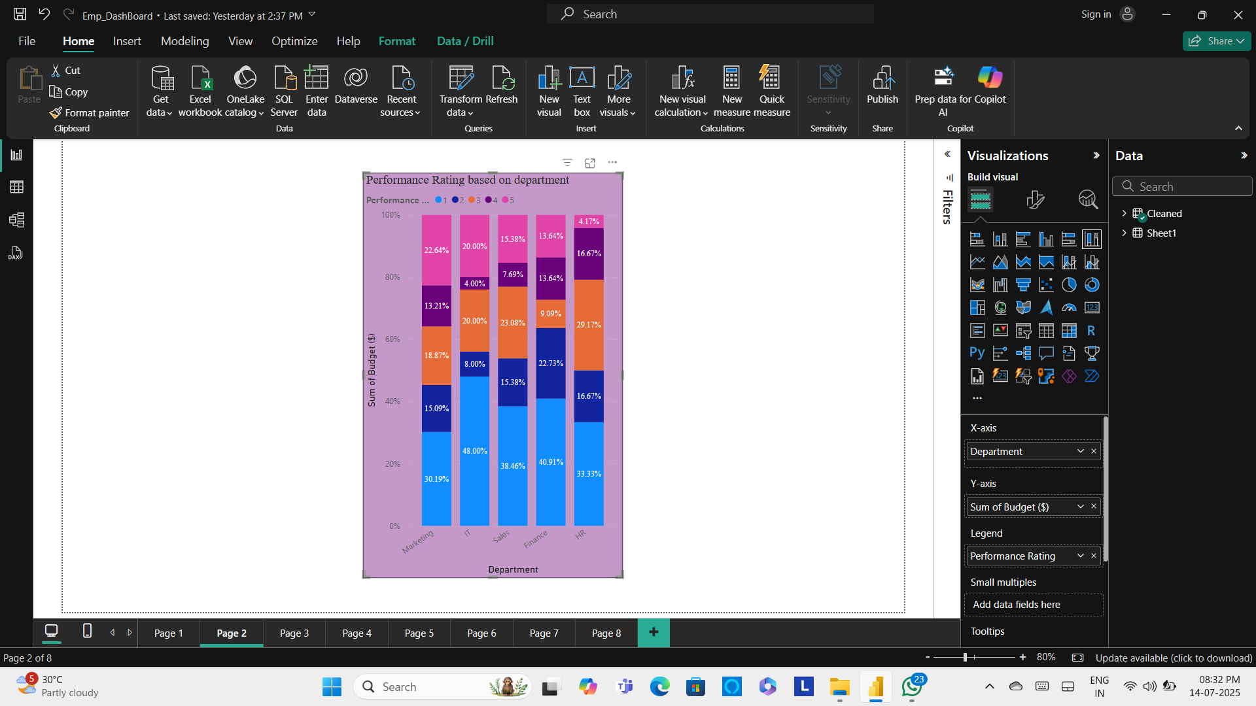

3) Treemap :

The average salary was calculated separately for each gender.

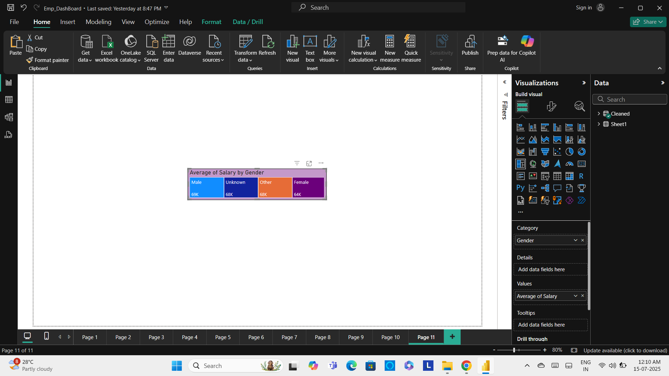

4) Map :

The average budget ($) was calculated for each country separately.

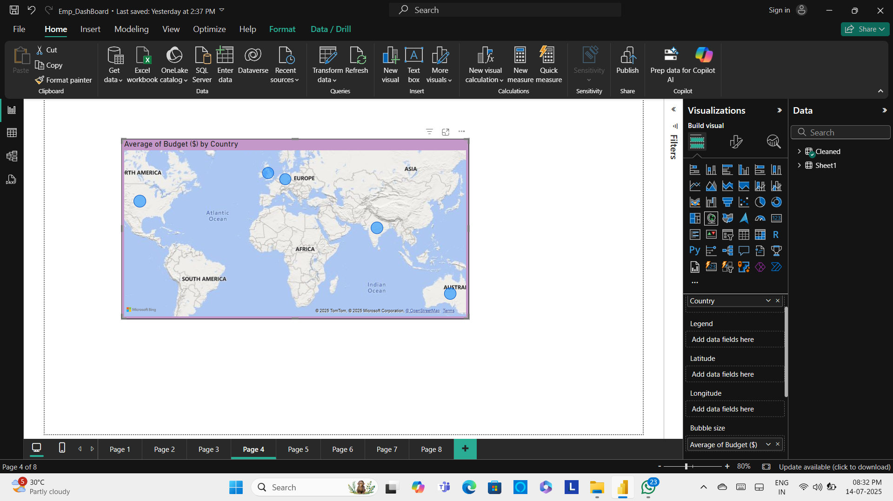

5) Line Chart :

A month-wise summary was created to show performance ratings along with the number of employees for each month.

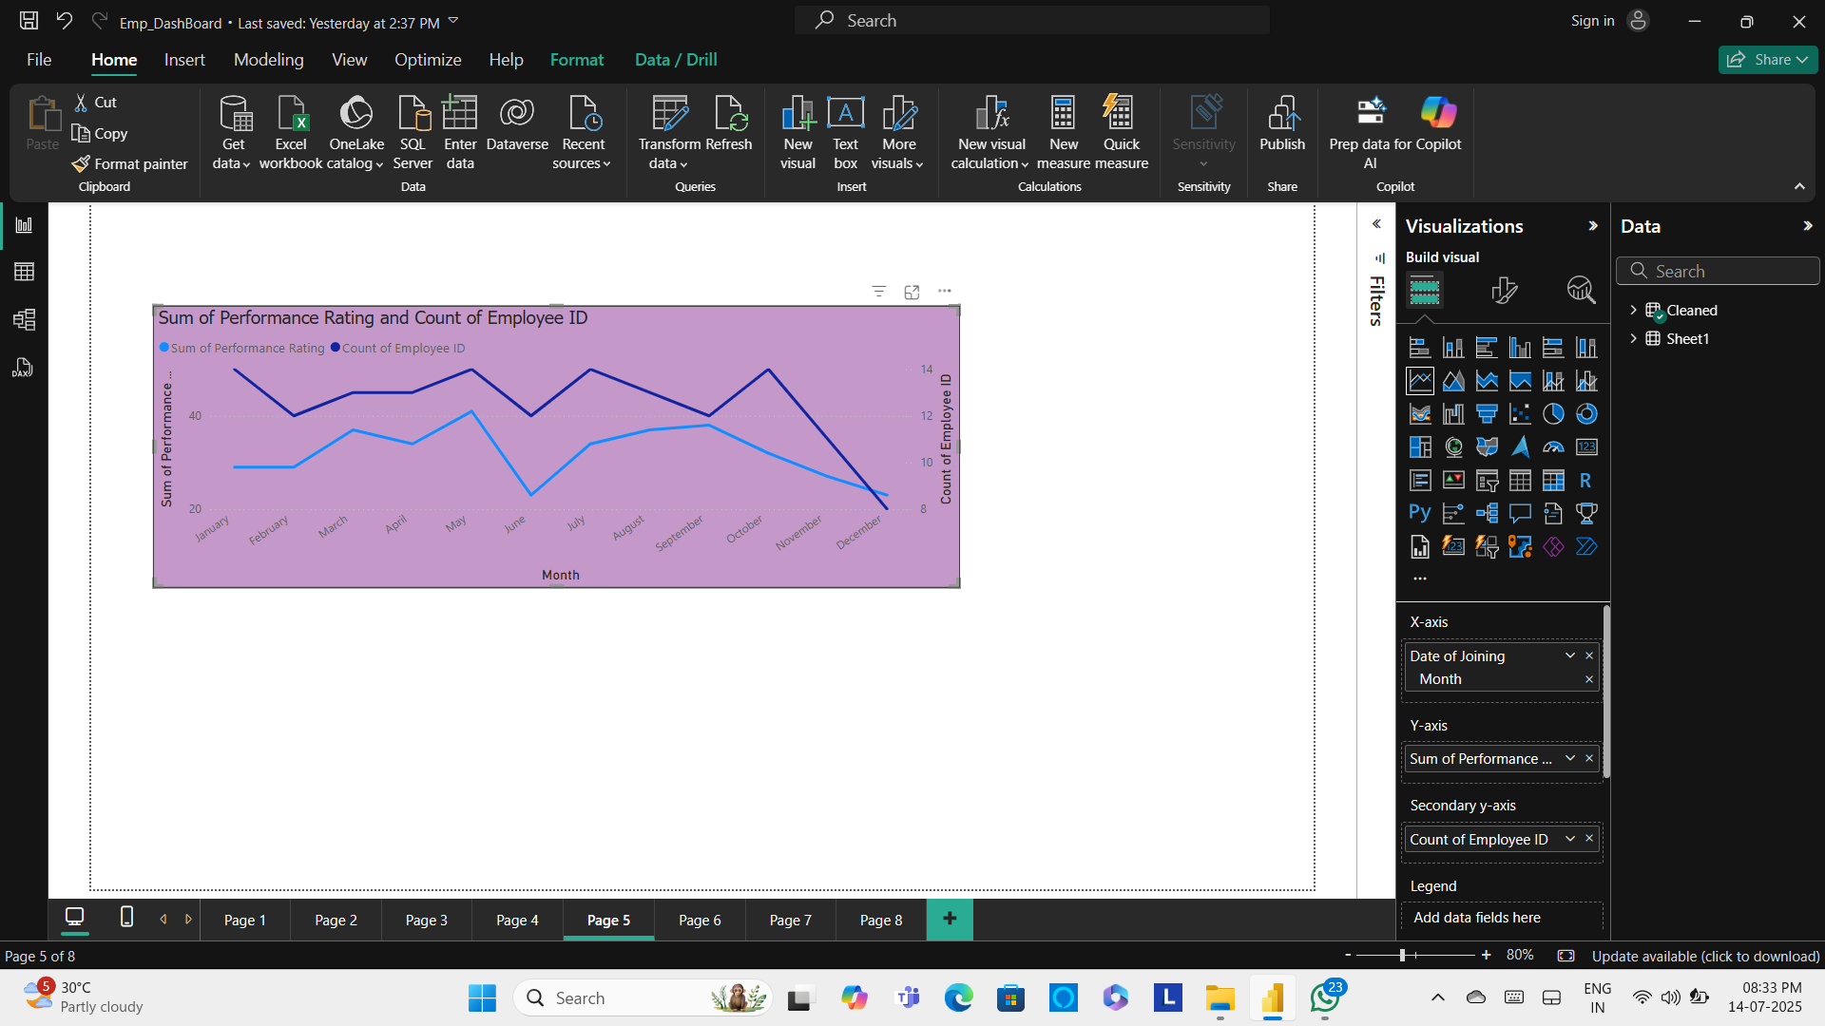

6) Card :

The total budget, total salary, and average incentive amount were each presented using separate card charts to provide a clear and concise visual summary of key financial metrics.

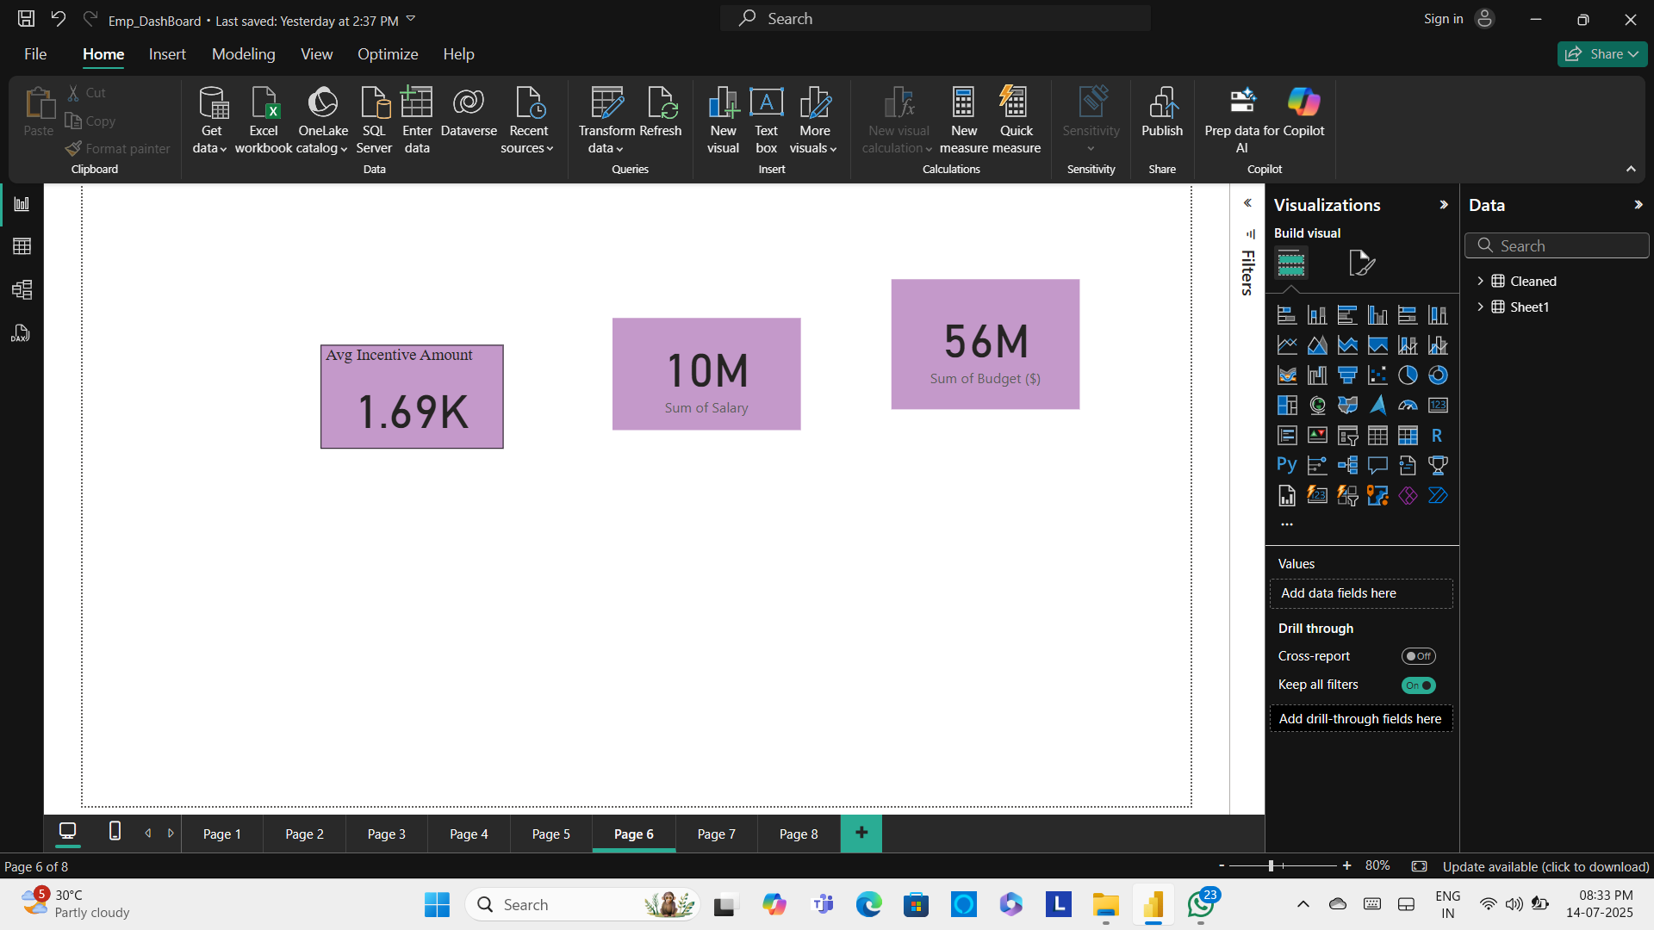

7) Matrix :

A matrix chart was created to display the average incentive amounts segmented by department and further broken down by gender within each department.

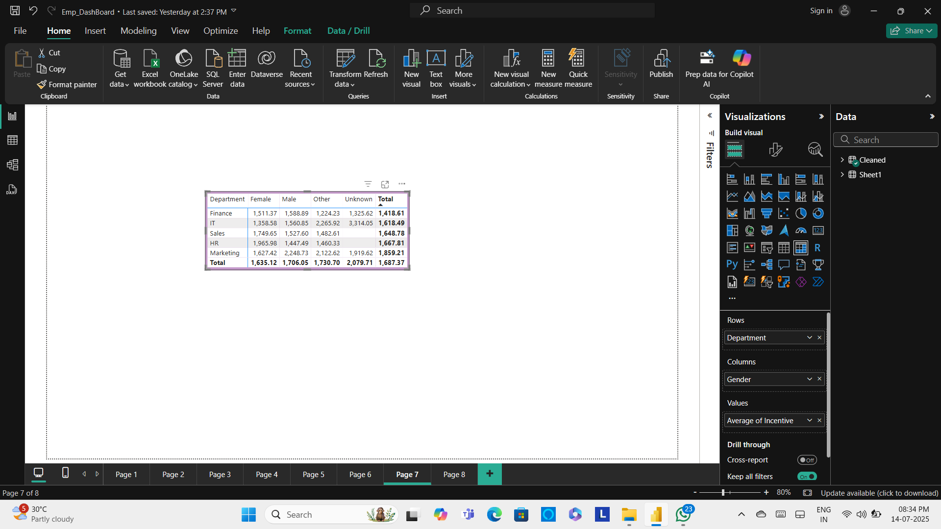

8) Slicer (Tile) :

A tile slicer was implemented for the department head, enhancing clarity and enabling more intuitive navigation across individual departments.

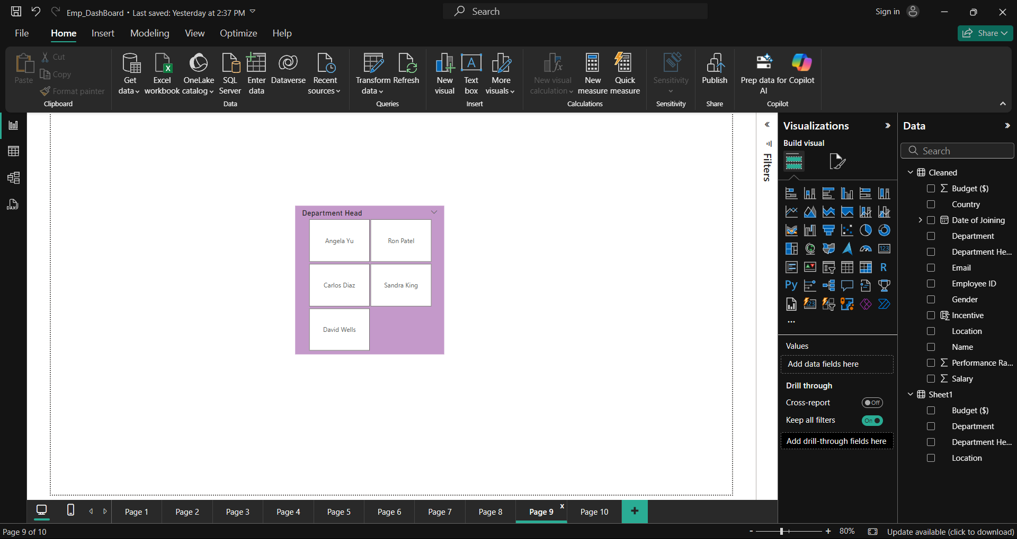

9) Slicer (Drop down) :

A drop-down slicer was utilized for Employee ID, allowing for streamlined and efficient selection from the list of employees.

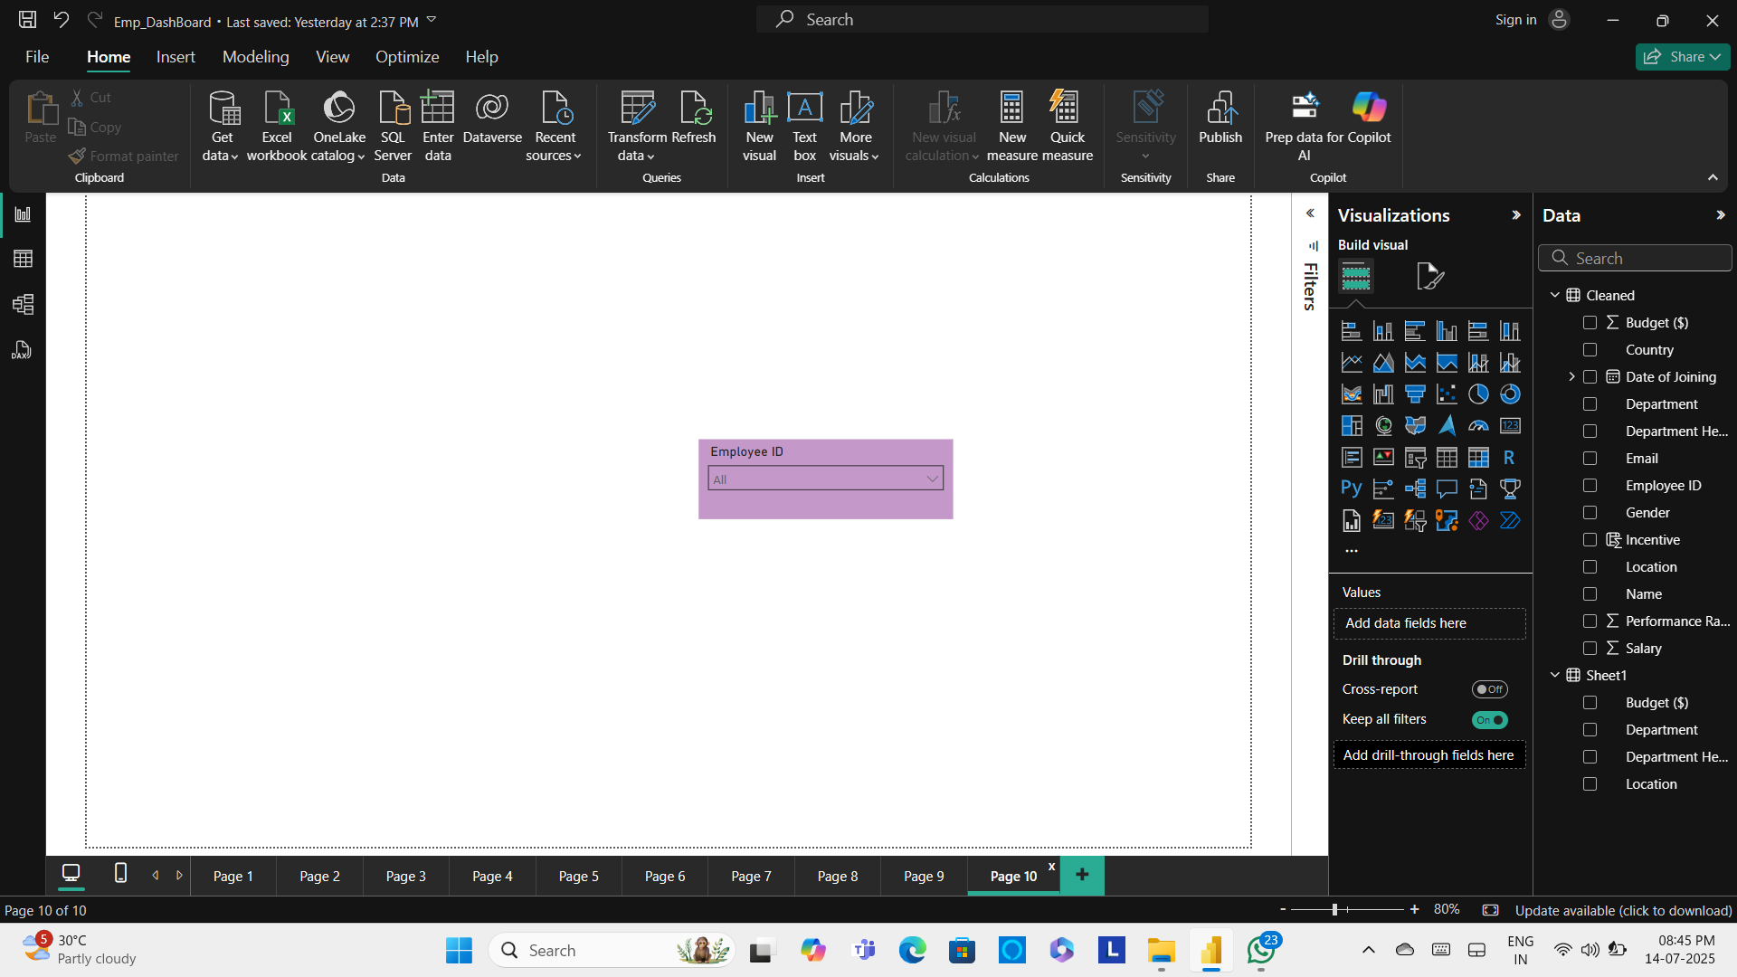

**Dash Board :**

The finalized Employment Dashboard presents a comprehensive overview encompassing detailed departmental information, profiles of department heads, expenditure alongside budgetary allocations, incentive and salary metrics, as well as budget distribution segmented by country, further complemented by gender-based analytical insights.

